Contents
1. Objective 2
2. Equipment Required 2
3. Control Theory and Applications 2
3.1 Analog Control 2
3.2 Time Response 2
3.3 Position Response 2
3.4 Frequency Response 2
3.5 Proportional Position Control 3
3.6 Behaviour of Second Order System 3
3.7 Digital Interfacing 3
4. Critical Analysis 3
4.1 Analog control – Equipment overview 3
4.2 Introduction to control system 3
4.3 Time response 5
4.4 Position response 6
4.5 Frequency response 7
4.6 Principal of feed back 8
4.7 Proportional Position control 9
4.8 Behaviour of second order systems 10
4.9 PID Control 11
4.10 Digital Interfacing 11
Key Takeaways 12
Possible Reasons for Error 12
Beyond The Manual 12

1. Objective
To study the control of DC motor digitally using Virtual Control Laboratory (VCL) software
via following experiments:
- Locate the analog features of the DC motor, Input potentiometer and interface modules, making the required connections.
- Getting to know the equipment and operate VCL
- Study the time response of DC motor
- Study the frequency response of DC motor
- Closed Loop Feedback control of DC motor
- Proportional Position Control of DC motor
- Study the behaviour of second order system in context of DC motor
- Position Control with velocity feedback
- PID Control

2. Equipment Required
- MS15 DC Motor
- CLIO interface
- AS3 command potentiometer
- Computer VCL software

3. Control Theory and Applications

3.1 Analog Control
- A constant DC voltage applied to DC Motor induces a constant torque which causes our motor to rotate at constant speed, which is measured using the tacho generator.
- The command potentiometer is used to manually provide input signal to drive the motor.
- The virtual instrumentation is used to the response of the created control system to the input signal.

3.2 Time Response
- In step response, we know from theory that there is a first order time lag.

- Factors affecting time constant: Inertia of the rotating part and the viscous friction of the bearing will affect the time constant by increasing it as the these will provide resistance to the desired motion of the motor.

3.3 Position Response
- This is not used generally as in the motor when velocity is constant, then the position will be continuously changing, and it is always difficult to measure something that is continuously moving.

3.4 Frequency Response
- When sinusoidal input is applied, then at output we get a sinusoid with different amplitude, phase but same frequency. At lower frequencies the gain is constant and there is no phase shift whereas at higher frequencies the gain reduces and there is a 90◦ phase shift acquired
- The frequency at which the gain starts to reduce is called the break frequency and is the inverse of time constant.

3.5 Proportional Position Control
- Transfer Function =
- In transient analysis, the system becomes less stable due to integration effect. This is because, after the motor stops, the transient does not stop due to inertial effect, making the system unstable.

3.6 Behaviour of Second Order System
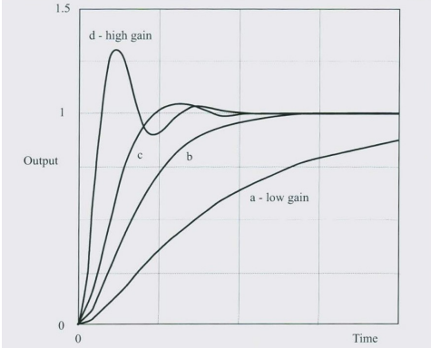
Figure 1: Variation of step response with proportional gain for second order system
- When the gain is low, the response is s Variation of step response with proportional gain for second order system sluggish and the system is said to be overdamped. An overdamped response is characterized by two-time constants.
- The fastest response is when the system is critically damped. It is characterized by two identically valued time constants.
- Damped frequency of oscillation, the frequency at which an underdamped system oscillates is called its damped frequency.

3.7 Digital Interfacing
- Pulse width modulation PWM provides a digital drive to the motor. The average value of a periodic two-level signal depends on its ON/OFF ratio.
- When the pulse train is averaged using an analog filter, the average value goes from full ON to full OFF.

4. Critical Analysis

4.1 Analog control – Equipment overview

4.1.1 Command potentiometer: relation between degrees and volts
We have following values of offset at 0V and 1V
Offset – Degrees at 0V | Degrees at 1V | Gain - degrees/volt
192.5° | 240° | 47.5°
Gain = 47.5° deg/volt

4.2 Introduction to control system

4.2.1 Reaching desired output
We would like to run motor at half speed for this tacho output must be 2.5V (50% of maximum voltage). For this input voltage required is:
Offset | Input voltage | Output voltage
0 | 0 | -0.01
10 | 0.5 | 0.237
20 | 1 | 0.727
30 | 1.5 | 1.225
40 | 2 | 1.737
50 | 2.5 | 2.228
60 | 3 | 2.737
70 | 3.5 | 3.265
80 | 4 | 3.785
90 | 4.5 | 4.272
100 | 5 | 4.782

Figure 2: Graph between output and input voltage
From the graph we can see that for output voltage to be 2.5V input voltage must be nearly equal to 2.75V.

4.2.2 Reacting to load changes
We have following change of speed with load
Load | Tacho voltage
No load | 2.255
Half load | 1.862
Full load | 1.387
We can see that with different loading we cannot keep constant speed with open loop motor. Hence, with changing load we cannot use open loop motor for constant speed operation.

4.3 Time response

4.3.1 Steady state response
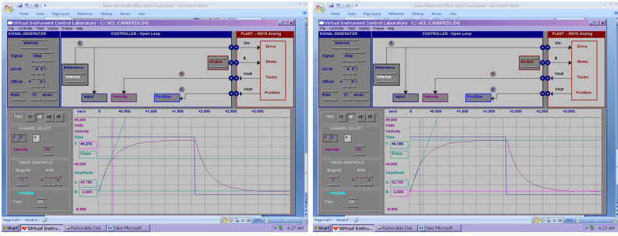
Figure 3: Measurements for steady state response
Input span = A1 - B1 = 6V
Output Span = A4 – B4 = 2.75 – (-2.75) = 5.5V
Hance the gain is:

4.3.2 Transient response

4.3.2.1 Using initial slope method
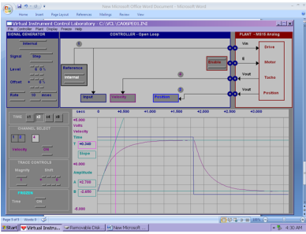
Figure 4: Time constant measurement via initial slope method
From above measurement, we get the time constant, = 0.335 sec.

4.3.2.2 Using settling time method
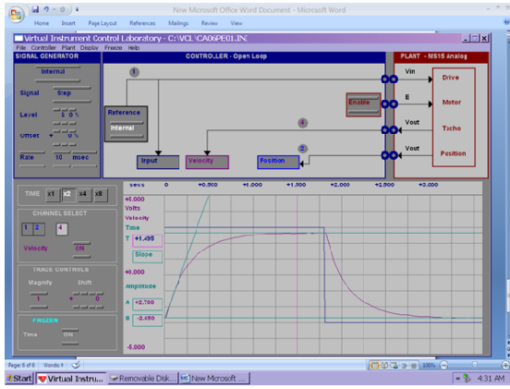
Figure 5: Time constant measurement via settling slope method
From above measurement, we get the time constant, = 1.175/5 = 0.235 sec.

4.3.2.3 Using 63% method
63% of output voltage = 0.63*(A4-B4) + B4 = 0.63*5.5 -2.75 = 0.715
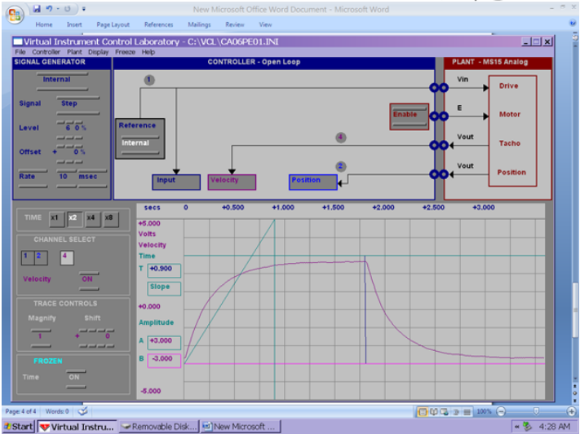
Figure 6: Time constant measurement using 63% method
From the above measurement, we get the time constant, = 0.27s
 |  |  | Input Span | Output span | Gain
0.335 s | 0.235 s | 0.27 s | 6 V | 5.5 V | 0.916
63% method gives more accurate measurement as compared to other methods. Hence, we will use the value of only.
Hence, the results are:
Plant gain, | 0.916
Time constant, | 0.27s

4.4 Position response
Velocity = 112 rpm.
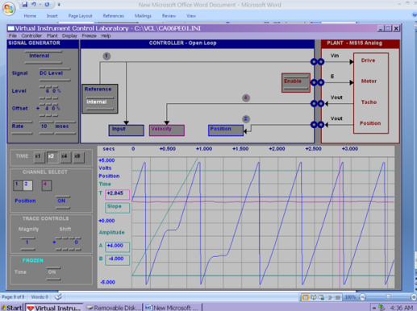
Figure 7: Position response
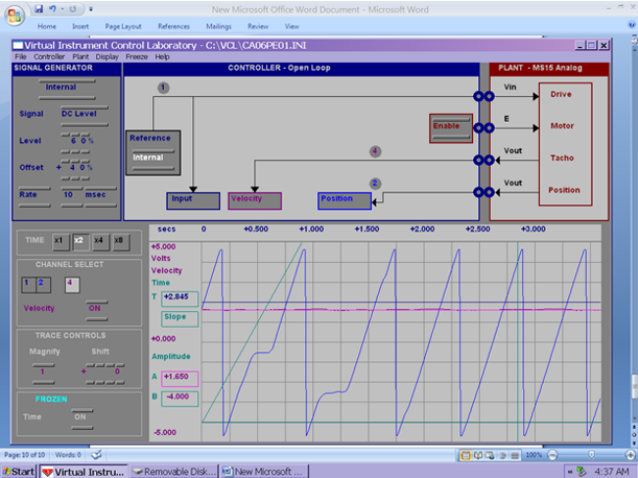
Figure 8: Tacho generator output
We got the following readings:
A (V) | B (V) | T1 (s) | T2 (s) | Slope (V/s)
4 | -4 | 0.6 | 1.025 | 18.82 | 1.75 | 10.756
Slope is calculated as: and is calculated as .

4.5 Frequency response
Input peak-to-peak voltage = 6V
Frequency (in Hz) | Output pk-pk | Phase lag (in deg) | Amplitude ratio | Amplitude ratio (in dB)
0.01 | 5.6 | 2 | 0.933 | -0.599
0.02 | 5.5 | 4 | 0.916 | -0.755
0.05 | 5.5 | 5 | 0.916 | -0.955
0.1 | 5.4 | 7 | 0.900 | -0.915
0.2 | 5.2 | 16 | 0.866 | -1.243
0.5 | 4.1 | 40 | 0.683 | -3.307
1 | 2.8 | 63 | 0.467 | -6.619
2 | 1.6 | 86 | 0.267 | -11.480
5 | 0.7 | 127 | 0.116 | -18.661
10 | 0.3 | 162 | 0.050 | -26.020
From the above readings, we have following bode plot:
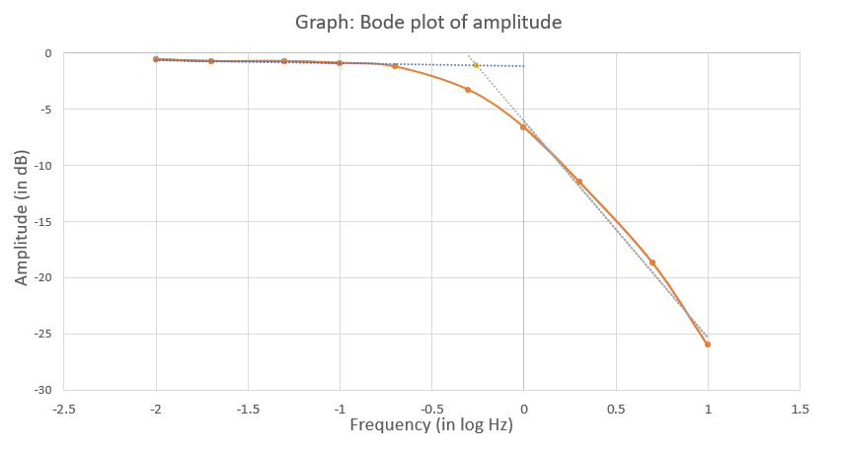
Figure 9: Bode plot of amplitude
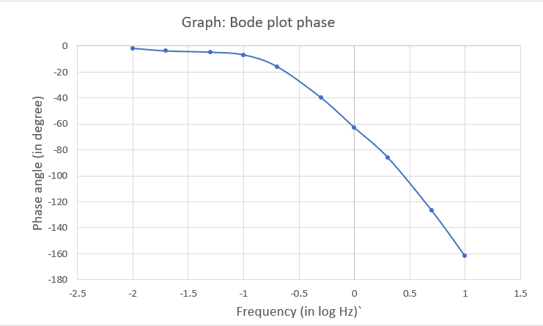
Figure 10: Bode plot of phase
Calculating the break frequency from 3 methods we have:
From slope | From -3 dB point | From -45° | Average
0.549 | 0.562 | 0.575 | 0.562

4.5.1 Comparison of time and frequency constant
For frequency response, gain is found as amplitude ratio at low frequency = 0.92 and time constant is found as
 | Time response | Frequency response
Plant gain | 0.916 | 0.92
Time constant (in second) | 0.27 | 0.28

4.6 Principal of feed back

4.6.1 Closed loop performance – Steady state response
The input voltage applied to plant is 2.5V i.e., R = 2.5.
Also, we have = 0.918.
Gain | Velocity, C  (in V) | Error, E  (in V) | C/R  Theory | C/R | E/R  Theory | E/R
1 | 1.1 | 1.47 | 0.479 | 0.44 | 0.521 | 0.588
2 | 1.54 | 0.97 | 0.647 | 0.616 | 0.353 | 0.388
5 | 2.03 | 0.48 | 0.821 | 0.812 | 0.179 | 0.192
10 | 2.24 | 0.25 | 0.902 | 0.896 | 0.098 | 0.1
20 | 2.38 | 0.13 | 0.948 | 0.952 | 0.052 | 0.052
50 | 2.49 | 0.01 | 0.979 | 0.996 | 0.021 | 0.004
100 | 2.49 | 0.01 | 0.989 | 0.996 | 0.011 | 0.004
Theoretically we found C/R and E/R as:

Where K is gain
In line with predictions, as the gain increases, C/R 1 and E/R 0. But with high gain motor starts making peculiar noise.

4.6.2 Closed loop performance – transient response
We have time constant, = 0.27 and gain, .
Gain | Time constant | Theoretical Time constant
1 | 0.12 | 0.14
5 | 0.06 | 0.04
We have calculated theoretical time constant as , where K is gain.
We can see that with increasing gain time constant decreases and theoretical value is nearly same as experimental value.

4.7 Proportional Position control
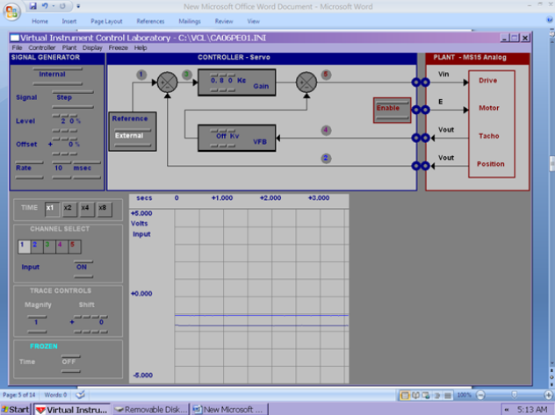
Figure 11: System input and position for a position of command potentiometer

4.7.1 Steady state response
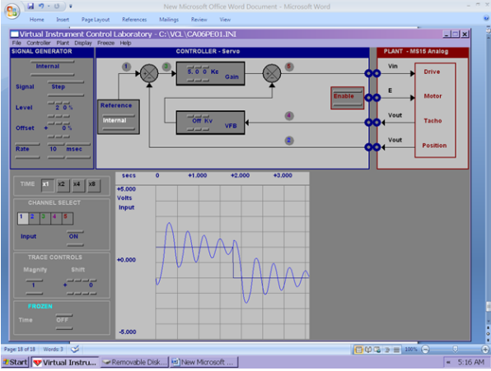
Figure 12: Step input response with
Response produced here is different form the one produced in proportional speed control system
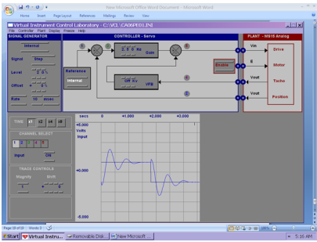
Figure 13: Step input response with = 2.5
Even with low gain, steady state condition is meet.
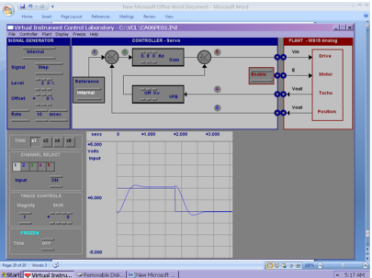
Figure 14: Step input Table 1response with = 0.8
On further increasing gain, the traces get smoother i.e., not much oscillation in transient state

4.7.2 Transient Response
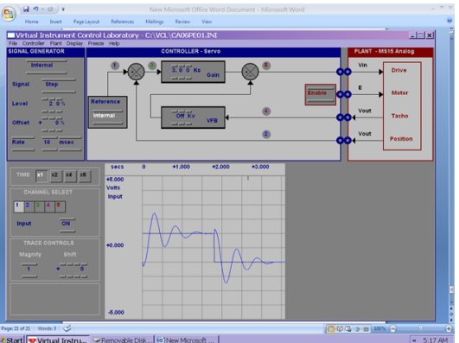
Figure 15:
Even though steady state is reached, transient response is too much oscillatory.
On changing load, we found the at a given gain one load may reached steady state but on changing load system would be oscillatory or will not reach steady state.

4.8 Behaviour of second order systems
We set gain and using marker we have following readings,
Maximum voltage, = 4.5 V
Steady state voltage, = 3.0 V
Peak time, = 0.41 s
Gain, | Overshoot |  | second | rad/sec | rad/sec
1.5 | 50.0% | 0.215 | 0.41 | 7.66 | 7.846
Combining all the values of plant, we have
1.5 | 0.918 | 10.7 | 3.703 | 0.254 | 7.846

4.9 PID Control

4.9.1 Proportional control
With only proportional control, there is considerable error between input and output. The error decreases with increasing gain but starts to pick noise.

4.9.2 Integral control
Adding integrator in parallel decrease the error and with integral time constant is of order 0.1 error nearly gets eliminated.

4.9.3 Derivative control
We seen that with plant substituted with P+I control derivative control helps to reduce overshoot and decreases transient response i.e., reducing transient response.
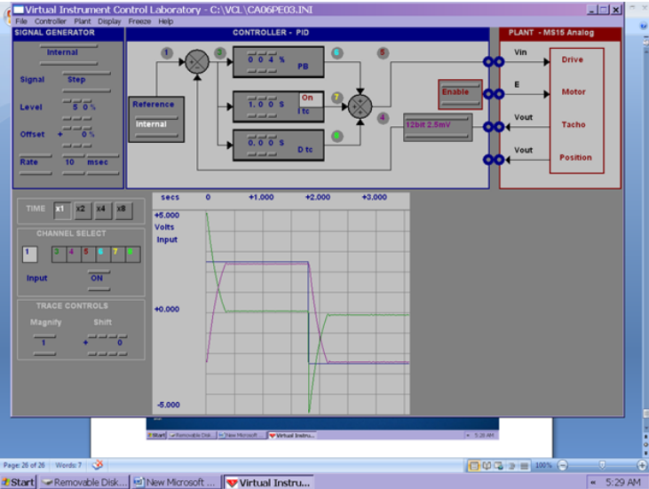
Figure 16: System response with only P controller
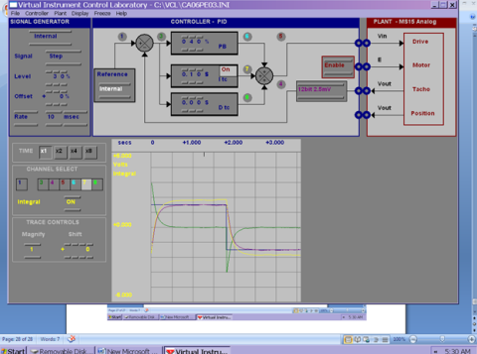
Figure 17: System response with P+I controller
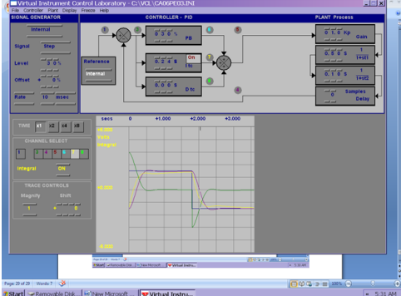
Figure 18: system response with P+I+D controller

4.10 Digital Interfacing

4.10.1 PWM drive
Offset (%) | Pulse interval (ms) | Tacho output (V)
0 | 1.5 | 1.304
10 | 1.55 | 1.369
20 | 1.6 | 1.434
30 | 1.65 | 1.499
40 | 1.7 | 1.564
50 | 1.75 | 1.629
60 | 1.8 | 1.694
70 | 1.85 | 1.759
80 | 1.9 | 1.824
90 | 1.95 | 1.889
100 | 2 | 1.954

Figure 19: Graph of tacho output and pulse interval

Key Takeaways
- In this experiment we learnt the functioning of different kinds of control systems using a digital software for tracking output response to an input signal.
- Throughout different experiments, our output responses complied with the theoretically expected output within experimental limits as shown in Critical Analysis.
- We studied each of the three controllers - proportional, integrative, and derivative separately and also together and we obtained the steady state and transient state responses in accordance with our theoretical calculations.

Possible Reasons for Error
- If the equipment is faulty, application of brakes on the motor may not give the expected outcome
- Old equipment generally does not give much accurate readings.
- Rapid change of command potentiometer readings may result in wearing of the motor wheel due to changing directions of rotation. (Backlash Error)
- Non-linearity in motor system.

Beyond The Manual
- There are a variety of applications for digital control system, such as in power generation, water, metal processing, cement, food, and manufacturing industries are shown. The text also covers applications in robotics, biomedicine, monitoring and failure detection, fuel optimization and heat control, adaptive process control, modelling, and computer software.

